Requesting an Interlibray Loan

Making a request
Search for the book
Request the book. | - Click on the title to show the locations.  - Click the Request button.  - Enter your patron's barcode.  - Click the Complete the Request button.

Unfilled requests
Check for unfilled requests
Try next lender | If more potential lenders are available, there will be a Try next lender button.
Cancel request | If there are no further potential lenders (or you simply want to cancel the request), click the Cancel request button.

When the books come in
Receiving | 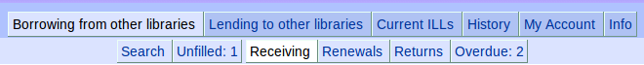
Choose slip printing | Click on one of Individual slips (default), Mulitple slips on a page, or Do not print slips. These are the date-due slips you can put in the book for your patron.
Receive the books | Click the Receive button for that book. If you have selected Individual slips, a date-due slip will be printed. If you have selected Multiple slips on a page, a button called Print now will appear under Printing of Date-Due Slips; you can click it at any time to print any accumulated slips (shown below the Receiving table).
Note | You do not need to create any kind of cataloguing record in your ILS. You will be have access to your ILL request statistics through fILL.

Requesting a renewal / Checking status of Renewal requests
Renewals
Find the request | In the Search box (upper right), enter the patron's barcode number or some keywords from the title of the book you would like to renew. You can also sort the list by status, by clicking on the Status heading.
Ask for renewal | Click the Ask for renewal button. Your request will be added to the lending library's Renewal requests list.
Status of renewal request | The status column will show one of:  - Received (with an Ask for renewal button),  - Renew-Answer | Ok (with a new due date), or  - Renew-Answer | No-renewal (possibly with a message from the lender).

Returning the book to the lending library
As part of your ILL returns procedure
If you have a lot of ILLs to return | Enter some keywords from the title into the Search box (upper right)
Mark it as returned | Click the Return button.

Overdue items
Check for overdue items | 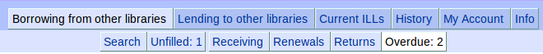

Overrides

If you receive a book but it is not in your Receiving list
The lender did not mark it as Shipped. | - Override this by going into Current ILLs => Current Borrowing.  - Click the + button in the Overrides column (right side) for that ILL.  - Click the Receive button.  - Proceed with When the book comes in, above.

If you get an overdue for a book you have returned
The lender did not mark it as Checked-in. | - Override this by going into Current ILLs => Current Borrowing.  - Click the + button in the Overrides column (right side) for that ILL.  - Click the Close button to close the ILL transaction. (The ILL gets moved to History)

Filling interlibrary loan requests from other libraries

Pulling items from your shelves
Show new requests | 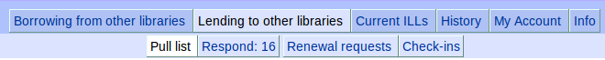
Suggested procedure | - Print entire pull list: click the Print button at the top of the list (formats the screen for printing), and then use your web browser's print function.  - Press the ESC (escape) key to exit the screen-printing format.  - A you pull books from the shelves, mark on the printed sheet any items you will not loan (and why). Standard reasons include:  - in use / on loan  - in process  - lost  - non-circulating  - not owned  - not on shelf  - on reserve  - poor condition  - charges (i.e. You are willing to loan it, but will charge a fee)  - on hold  - policy problem (e.g. too new, or don't loan this type of material, etc)  - other  - Proceed to Responding to interlibrary loan requests, below.
Notes | - You can check / print this list at any time. Any requests that you have not yet responded to will show up here.  - The list is in call # order by default. You can change the sort order by clicking on the various column headings.  - The list includes scannable patron barcodes for the requesting libraries (if you have entered these barcode numbers, taken from your ILS).

Responding to interlibrary loan requests
Send a response to the requesting library | 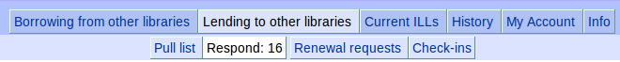
Check out in your ILS | Check out the items to the requesting libraries; note the due date.
Set a default due date | This will set the due date for all requests that you send. Set it to match the due date from your ILS. If you have different due dates for different types of items, set the default due date for one type and respond to all of those. Then change the default due date and respond to the rest.
Requests you are filling | Find the item in the list, and click the Send buton
Requests you will not fill | Find the item in the list, click the Unfilled button, and then click on the reason and Submit.

Responding to renewal requests
List of renewal requests | 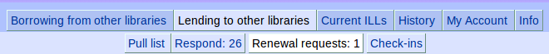
Set a default due date | As in Responding to interlibrary loan requests, above.
Requests for which you will allow a renewal | - Click the Renew OK button.
Requests for which you will not allow a renewal | - Click the Can't renew button.  - [Optional] Enter a note to the requesting library.  - Click the Submit button.

When the book comes back
Close the ILL transaction | 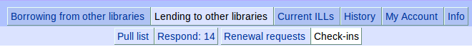  - Find the request and click the Check-in button. (The ILLgets moved to History)  - Then check the item in in your ILS.

Overrides

If the borrower has returned the book, but it is not in your Check-in list
The borrower did not mark it as Returned. | - Override this by going into Current ILLs => Current Lending.  - Click the + button in the Overrides column (right side) for that ILL.  - Click the Returned button.  - Proceed with When the book comes back, above.

